**NATIONAL INSTITUTE OF TECHNOLOGY SILCHAR**

**Cachar, Assam**

**B.Tech. IVth Sem**

**Subject Code:** CS215

**Subject Name:** Signals and Data Communication

**Submitted By:**

Name : Subhojit Ghimire

Sch. Id. : 1912160

Branch : CSE – B

1. **Consider a bird sanctuary where migratory birds arrive during winter season which spans over 4 months. Suppose “a%” of the birds starting from their home-place make it alive into the sanctuary. The birds mate, female bird lay two eggs (male-female ratio is 1:1) and chicks hatch after one (01) month. 50% of the chick survive and “b%” of these chicks join the flock of arriving birds. Within next one month “c%” of the birds (not the chicks) die within next one (01) month. Use MATLAB to report variation in bird population in the sanctuary with respect to varying chicks joining arriving birds. Also, report bird population in the sanctuary with respect to varying death rate of birds. (You are free to choose values but the values chosen should be reported with justification.)**

* **AIM: TO PLOT VARIATION IN PRESENT BIRD POPULATION W.R.T. NEWLY JOINING CHICKS AND PRESENT BIRD POPULATION W.R.T. DEATH RATE OF BIRDS.**

**THEORITICAL BACKGROUND:**

**Plot:** A plot is a graphical technique for representing a data set, usually as a graph showing the relationship between two or more variables.

**Sub-plot:** A subplot divides the current figure into rectangular planes that are numbered row-wise.

**METHODOLOGY:**1. An initial point is taken and an interval is taken.  
2. The a% and b% are assumed and the empty vector is initialised.  
3. For a varying bird population, the input is taken.  
4. Monthly plotting is done for the first two months.  
5. Bird population vs Death Rate for the two subsequent months are plotted.

**CODE:  
  
%sdc3x.m**  
function x = sdc3x(t,a,b)

x = (b*a*t)/20000;

end **%sdc3y.m**function y= sdc3y(t,a)

y = 3*a*t/200;

end  
  
**%sdc3y2.m**  
function y2 = sdc3y2(a,t,c)

y2 = (3*a*t)/200 - (c*a*t)/10000;

end  
  
**%drfm.m**  
function y3 = drfm(a,t)

y3 = (a*t)/200;

end **%drsm.m**function y4 = drsm(a,t,c)

y4 = a*t/200 + c*a*t/10000;

end  
  
**%main program**close all;

clear all;  
clc;

birds =[100:5:400];

a = 60; b=20; c = 10;

x=[]; y=[]; y2=[];

i=1;

for t = 100:5:400

x(i) = sdc3x(t,a,b);

y(i) = sdc3y(t,a);

y2(i) = sdc3y2(a,t,c);

i = i+1;

end;

subplot(3,2,1);

plot(y,x);

title('for first month');

xlabel('chick joining arriving birds');

ylabel('birds population in sanctuary');

subplot(3,2,2);

plot(y2,x);

title('for second month');

xlabel('chick joining arriving birds');

ylabel('birds population in sanctuary');

birds =[100:5:400];

a = 60; b=20; c = 10;

x=[]; y=[]; y2=[]; y3=[]; y4=[];

i=1;

for t = 100:5:400

x(i) = sdc3x(t,a,b);

y(i) = sdc3y(t,a);

y2(i) = sdc3y2(a,t,c);

y3(i) =drfm(a,t);

y4(i) = drsm(a,t,c);

i = i+1;

end;

subplot(3,2,3);

plot(y,x);

title('for first month');

xlabel('chick joining arriving birds');

ylabel('birds population in sanctuary');

subplot(3,2,4);

plot(y2,x);

title('for second month');

xlabel('chick joining arriving birds');

ylabel('birds population in sanctuary');

subplot(3,2,5);

plot(x,y3);

title('for first month');

xlabel('death rate of overall bird');

ylabel('birds population in sanctuary');

subplot(3,2,6);

plot(x,y4);

title('for second month');

xlabel('death rate of overall bird');

ylabel('birds population in sanctuary');

**INPUT DATA DESCRIPTION:**The birds population is taken from initial point 100, with increasing interval of 5. a% is taken to be 60 and b% is taken to be 20.

**RESULT:  
  
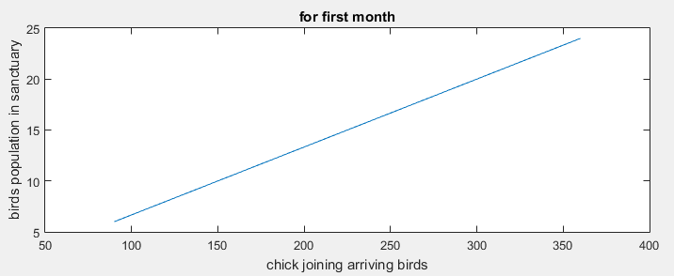**   
  
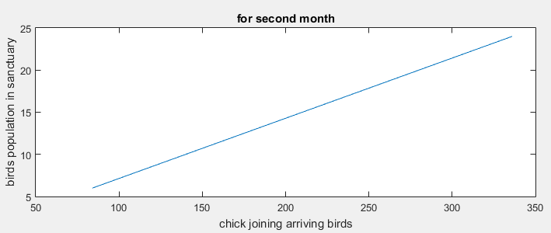   
  
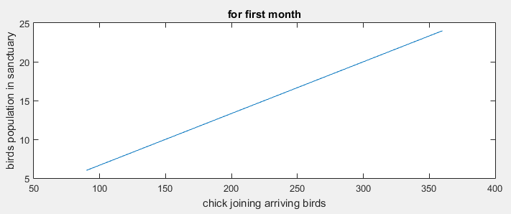   
  
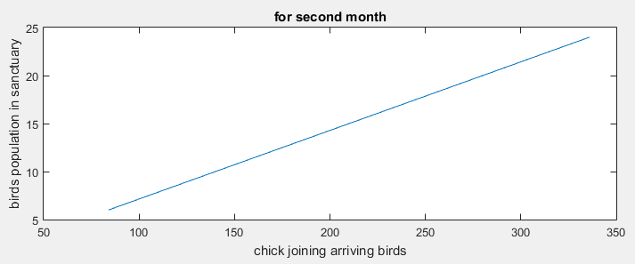 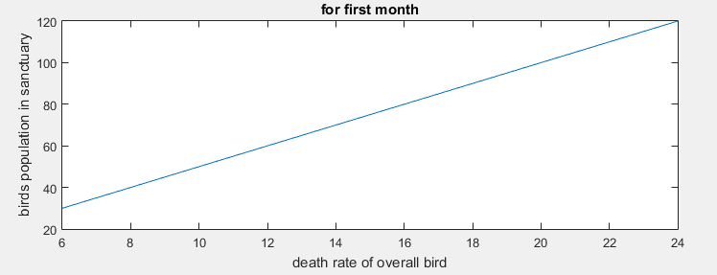   
  
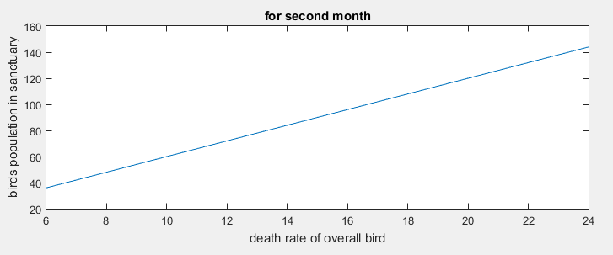  
  
 **CONCLUSION/DISCUSSION:**The graph is obtained for the arriving bird vs bird population in the sanctuary for the first two months. Similarly, the graph for death rate vs bird population for the first two months is obtained.